Strategy
(Behavioural)

The strategy design pattern is a behavioural pattern used when we need to dynamically select between different behaviours at runtime.
Essentially, the client code can select which behaviour should be used, without interfering with the code of the behaviours themselves.
Example use cases for using the strategy pattern would be choosing between different sorting algorithms depending on your input data, saving files in different formats, or selecting between different data validation methods.
Here’s the definition from the Head First Design Patterns book:
The Strategy Pattern defines a family of algorithms, encapsulates each one, and makes them interchangeable. Strategy lets the algorithm vary independently from clients that use them.
There are three main participants in the strategy pattern:
- Strategy – declares an interface that all supported strategies/algorithms must implement. A Context will use this interface to select a concrete strategy at runtime.
- Concrete strategy – implements an algorithm defined by the Strategy interface.
- Context – client code that keeps a reference to a Concrete strategy object, thus selecting at runtime which algorithm should be used.

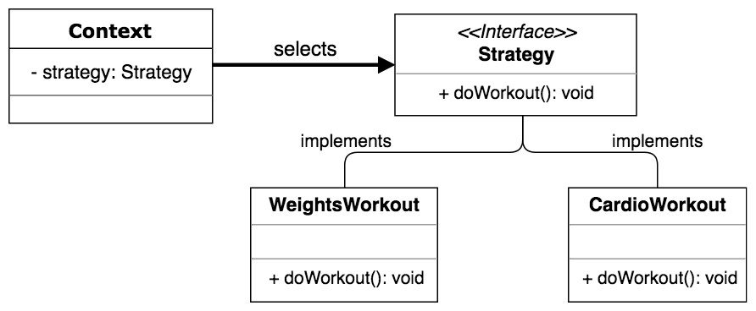

Pros
- select algorithms at runtime – as we’re relying on composition instead of inheritance, the client code has more flexibility in terms of having the ability to select which strategy to select depending on different conditions.
- separation of concerns – the different algorithms are separated and the client code is not aware of how a behaviour is implemented.
Cons
- client code must know which strategy to choose.
- increased code complexity due to extra classes.

Step 1
public interface Strategy {
void doWorkout();
}

Step 2
public class WeightsWorkout implements Strategy {

@Override
public void doWorkout() {
System.out.println("Workout using weight lifting strategy...");
}
}
public class CardioWorkout implements Strategy {

@Override
public void doWorkout() {
System.out.println("Workout using cardio strategy...");
}
}

Step 3
public class Context {
private Strategy strategy;

public Context(Strategy strategy) {
this.strategy = strategy;
}

public void executeStrategy() {
return strategy.doWorkout();
}
}

Step 4
public class StrategyPatternDemo {
public static void main(String[] args) {
// Select Weights strategy.
Context context = new Context(new WeightsWorkout());
context.executeStrategy();

// Select Cardio strategy.
context = new Context(new CardioWorkout());
context.executeStrategy();
}
}

Step 5 (output)
Workout using weight lifting strategy...
Workout using cardio strategy...
In conclusion, we have to remember that:
- Strategy pattern defines a family of behaviours.
- Strategy pattern makes it easy to switch between behaviours at runtime.

Resources:
https://dragonprogrammer.com/design-patterns-java-strategy-pattern/

